DeKalb Intensive English Curriculum

Resources and Guidelines

1. Checklist for Unit Outlines p. 2
2. WIDA Standards p. 3
3. Audio-Lingual Content Elementary p. 4
4. Audio-Lingual Content 4-8 p. 5
5. Audio-Lingual Content 9-12 p. 6
6. Texts and Print Resources for use in Pilot Units p. 7
7. Software/Web resources for use in Pilot Units pp. 8-10
8. Thinking Maps p. 11
9. Formative and Summative Assessment Menu pp. 12-15
10. Common Core Anchor Standards p. 16
11. WIDA Performance Definitions p. 17-18
12. WIDA Example Topics and Genres 19-23
13. WIDA Can-Do Descriptors: Available at: <http://www.wida.us/standards/CAN_DOs/>

**DeKalb IE Curriculum**

**Project Checklist for Each IE Unit**

Please use this checklist to make sure units are complete and include a completed copy with each unit outline submitted.

Grade Levels: Unit: Date: Author/s:

|  |  |
| --- | --- |
| **Yes/No** | **Criteria** |
|  | 1. Can teachers easily understand the unit? Does it facilitate their planning and teaching? |
|  | 1. Does the unit address WIDA Can-Do descriptors for the level, the content and vocabulary of the Audio-Lingual assessment, and WIDA suggested topics and genres? |
|  | 1. Has the Grade Level team coordinated their work to assure that all Can-Do Descriptors levels 1-2 are addressed (with reiteration and review) in the two unit outlines |
|  | 1. Do lesson suggestions include both language and content objectives? |
|  | 1. Does the unit include formative and summative assessment suggestions to assess achievement of unit and lesson goals/standards? |
|  | 1. Does the unit suggest student products to include in portfolio to document mastery of WIDA Can-Dos, levels 1-2? |
|  | 1. Does the unit use a wide range of strategies from the strategies guide, especially the newcomer strategies? Has the Grade Level Team coordinated the plans to assure diverse use of teaching/learning strategies? |
|  | 1. Does the unit provide opportunities to develop students’ thinking, such as thinking maps and/or other graphic organizers? |
|  | 1. Does the unit recommend materials on the grade level cluster list, that are available to all teachers at those grade levels? Does the unit include other materials and resources that are available to all? Does the unit avoid recommending materials that are not available to all teachers at the level? |
|  | 1. Does the unit make use of available software for language and content learning? (See the list in the Resources and Guidelines document.) |
|  | 1. Does the unit include opportunities for learners to develop keyboarding skills, use productivity tools and software (such as word processing, data management, and presentation tools), and other applications for language learning? |
|  | 1. Does each lesson include suggestions for ways that teachers can differentiate for students with various strengths and proficiency levels? |
|  | 1. Does the unit outline format remain consistent with the template (font, spacing, color, alignment, etc.) Have spelling, grammar, etc. been checked? Have green place markers been replaced with black text? Have blue instructions been removed? Are references to resources in a format consistent with the model? |
|  | 1. Are all “green” parts of the unit outline template complete? |

|  |  |  |
| --- | --- | --- |
| **The WIDA English Language Development Standards** | | |
| **Standard** | | **Abbreviation** |
| English Language  Development  Standard 1 | English language learners communicate for Social and Instructional purposes within the school setting | Social and  Instructional  language |
| English Language  Development  Standard 2 | English language learners communicate information, ideas and concepts necessary for academic success in the content area of Language Arts | The language of  Language Arts |
| English Language  Development  Standard 3 | English language learners communicate information, ideas and concepts necessary for academic success in the content area of Mathematics | The language of  Mathematics |
| English Language  Development  Standard 4 | English language learners communicate information, ideas and concepts necessary for academic success in the content area of Science | The language of  Science |
| English Language  Development  Standard 5 | English language learners communicate information, ideas and concepts necessary for academic success in the content area of Social Studies | The language of  Social Studies |

## Audio-Lingual Content for Elementary Grades

1. **Conversation** (Greeting, name, address, phone number, school, grade, age, birthday names of siblings, permission to use bathroom, tell someone you are sick
2. **Colors** (point to, name)
3. **Numbers** (point to, name, to 100)
4. **Alphabet** (Recite, name capital letters; lower case letters
5. **Body** (point to, name hair, mouth, ears, eyes, nose, hands fingers, arms legs, feet)
6. **Calendar** (tell today’s date, today’s weather, name the seasons, name days of the week, number of months in one year)
7. **Commands** (stand up; shut the door; sit down; pick up the pencil)
8. **Animals** (dog, cat, snake, fish, butterfly…)
9. **Classroom objects and tools** (chair, desk, pencil, light, window, door, clock)
10. **Activities** (reading, writing, sitting, eating, playing)
11. **Clothing** (shoes, jacket, shirt, dress, pants, socks)
12. **Money** (name penny, nickel, dime, quarter)
13. **Write** (name, alphabet, numbers 1-30)
14. **Food** (hamburger, French fries, carrot, banana, salad)
15. **Utensils** (spoon, glass, fork, napkin)
16. **Toys** (ball, doll, balloon)
17. **Grooming** (hairbrush/comb’ toothbrush/toothpaste, soap, shampoo, deodorant, tissue/paper towel)

## Audio-Lingual Content for Grade Levels Cluster 4 - 8

1. **Places in the school** (office, cafeteria, bathroom/restroom, classroom, hall)
2. **Classroom objects and tools** (chair, computer, printer, flag, clock, stapler/staple, tape, glue, scissors, pencil sharpener
3. **Food/utensils**: strawberry, peach, banana, apple, tomato, corn, lettue, chicken, fish, hamburger, eggs, milk, cereal, fork, knife, spoon, bowl, up plate, napkin, rice)
4. **Number words**: (One to ten; one hundred, eventually one thousand.)
5. **Ordinal numbers** (to 3, 10, 20, etc. to one hundredth)
6. **Shapes** (triangle, rectangle, oval, square, diamond, circle)
7. **Clothing** (shirt, pants, skirt, dress, belt, jacket, shoes, socks umbrella, bookbag, backpack, scarf…)
8. **Animals** (dog, cat, snake, fish, butterfly…)
9. **Parts of the body** (hand, nose, leg, back, arm, hair, foot, finger, ear, eyes)
10. **Time** (using digital
11. **Measurement** (inch, foot, yard, gallon cup)
12. **Money**: ID and tell value of penny, nickel, dime, quarter, dollar
13. Recite and identify **letters of alphabet**
14. Make **polite classroom requests**, e.g., To use the restroom, To get help, To sharpen pencil
15. **Respond to commands** with actions, e.g.: Go to the door, Raise your right hand, Close the book, Turn the page, Stand up/sit down
16. **Family** – tell about your family with names and relationships

**Writing**

1. Write **personal information**: name and address, telephone number, name of school, student number, home school, lunch number, language(s) you speak
2. Write **calendar information**: days of the week, months of the year, seasons, today’s date
3. Write a paragraph introducing yourself.

**Audio Lingual Content for Grades 9-12**

**Part A: Oral, Grades 9-12**

**Oral Interview** (Name, greetings, age, address, telephone number, grade, school, student number, father’s name, mother’s name, number of brothers and sisters, sister’s names, brothers’ names, recite the Pledge of Allegiance, when arrived in Atlanta, request permission for restroom, ask for a pencil, tell teacher you are sick, ask to sharpen pencil, give birthday greeting)

**Calendar** (Answer questions with: date f birth, number and names of months, number and names of days of the week, today’s day and date, yesterday’s day and date, tomorrow’s day and date, current year)

**Commands** (stand, sit, open/close the door, open a book to the table of contents, turn to chapter x.

**Part B: Recognition**

**Classroom** (Point to: chalk, desk, board, light, window, floor, wall, shelf/bookshelf, pencil sharpener, ceiling, clock)

**Body Parts** (eyes, mouth, arms, head, feet, hands, legs, ears, fingers)

Food (peach, strawberry, orange, grapes, tomato, carrot, corn, potato, eggs, juice, soup, hamburger, cake bread, spoon, cup, glass, knife, napkin, fork)

**Colors** (black, blue, brown, green, orange, purple, red, yellow, white)

**Numbers** (to 200; dates)

**Alphabet** (recognize all letters)

**Actions** (write, read, sit, play, eat, run, walk, take the bus, wash hands, get dressed, drink water)

**Animals** (Bird, horse, cow, chicken, pig, fish)

**Money** (US coins, bills, change from a dollar)

**House and home** (living room, kitchen, bathroom, bedroom, stairs, closet, lamp, soap, refrigerator

**Clothing** (shoes, coat, jacket, shirt, dress, sweater, socks, pants, jeans, gloves

**Occupations** (principal, nurse)

**Transportation** (ship, train, airplane)

**Sports** (gymnasium, stadium football, soccer, swimming, basketball, baseball, gymnastics

**Part B: Writing, Grades 9-12**

**Write from dictation** (85, 18, school, homework, subject, English, mathematics, science, physics, chemistry, health, physical education, transcript)

**Draw shapes** (circle, square, triangle, rectangle)

**Personal Information** (Write first and last name, address, and telephone.)

**Paragraph** (Write a paragraph about yourself and / or your family.)

## Texts and Resources for Pilot IE Curriculum

In writing our pilot curriculum, we need to reference texts and supplementary resources that are available to all teachers/students in the target grade level cluster. They are included in this list.

We may also reference free websites, software and library materials that are accessible to all teachers/students at the school.

**Grades 3-5**

* ESOL/Reading: OWE (Grade 1 (for IE Grade 3) or Grade 2 (for IE Grades 4-5) with consumable student book and teachers’ materials and differentiated reading resources.
* OPDCA for Kids (in English) and TEs and WBs
  + OWE Leveled Readers (print and online)
  + HMH Leveled Readers (online)
  + Scholastic Leveled Readers (print)

**Grades 6-8**

* OPDCA English and bilingual Spanish, Workbook, Teacher’s Editions
* ESOL/Reading program: *Milestones Intro*, with TE, WB
* Teacher set of Oxford Illustrated Dictionaries for math, science, social studies and iTools
* Leveled readers
  + HMH Leveled Readers (Online)
  + Scholastic Leveled Readers (Print)
  + Teen Emergent Reading Library (Print)

**Grades 9-12**

* OPDCA English and bilingual Spanish, Workbook, Teacher’s Editions
* ESOL/Reading program: *Edge,* with TE, WB
* Teacher set of Oxford Illustrated Dictionaries for math, science, social studies and iTools
* Leveled readers
  + HMH Leveled Readers (Online)
  + Scholastic Leveled Readers (Print)
  + Teen Emergent Reading Library (Print)

## Websites/Software Resources available at the International Center

**Web List sent from library with ids/access codes**

* FolletShelf
* Pebble Go
* World Book Online
* World Almanac Online
* World Almanac for Kids
* Teaching Books.net
* BrainPop
* Galileo
* Enchanted Learning
* Discovery Education Streaming Video, Science
* OmniMusic
* Edmodo (and a number of apps are free through Edmodo)

**Software Available on School iPads**

* Sentence Builder
* Houghton Mifflin Harcourt Leveled Readers
* Sight Words
* Sight Cards
* iTranslate
* Phonics Lite
* Verb Mayhem (levels 1, 2, and 3)
* Oxford Picture Dictionary (Everyday Language)
* Make a Word
* ABC Train
* Whiteboard
* Math Zombies
* Flash to Pass
* Know Your Math Facts
* Math Adventure with Fast Facts
* Sushi Monster
* Genius Baby Flash Cards
* Khan Academy
* First Class

**Productivity Software Available at DISC**

* Word Processing (e.g., MSWord),
* Presentation Software (e.g., PowerPoint, Keynote, Prezi),
* Data Management Software (e.g., Excel),
* graphics software;
* Promethean and Active Inspire Software.
* Calculators.

**Web Resources**

Spelling City: <http://www.spellingcity.com/>

Songs for Teaching: <http://www.songsforteaching.com/index.html>

EL Civics: <http://www.elcivics.com/>

Activities for ESL Students:  [ [http://a4esl.org](http://a4esl.org/) ][http://a4esl.org](http://a4esl.org/)

Jefferson Lab (Science):  <http://education.jlab.org/index.html>

Enchanted Learning: <http://www.songsforteaching.com/index.html>

Teach the Children Well: <http://www.teachthechildrenwell.com/>

ABC Mouse: <https://www.abcmouse.com/schools>

Lanternfish ESL: <http://bogglesworldesl.com/>

Teacher Planet: <http://www.teacherplanet.com/>

MES English: <http://www.mes-english.com/>

ESL America: [ <http://www.eslamerica.us/> ]<http://www.eslamerica.us/>

ESL Point: <http://www.eslpoint.com/>

Starfall: <http://www.starfall.com/>

English for Everyone: <http://englishforeveryone.org/>

A Plus Math: <http://www.aplusmath.com/>

A Math Dictionary for Kids: <http://www.amathsdictionaryforkids.com/>

Cool Math for Kids: <http://www.coolmath4kids.com/>

Illuminations: <http://illuminations.nctm.org/>

Cool Math: [www.coolmath.com](http://www.coolmath.com/)

Math is Fun: <http://mathisfun.com/>

Math A Tube: <http://www.mathatube.com/>

That Quiz: [www.thatquiz.org](http://www.thatquiz.org/)

Math Drills: [ [http://www.math-drills.com](http://www.math-drills.com/) ][www.math-drills.com](http://www.math-drills.com/)

Math Playground: [ <http://www.mathplayground.com/>

]<http://www.mathplayground.com/>

Helping With Math: <http://www.helpingwithmath.com/>

National Library of Virtual Manipulatives: <http://nlvm.usu.edu/en/nav/vlibrary.html>

Typing Websites:

[www.bbc.co.uk/schools/typing/](http://www.bbc.co.uk/schools/typing/)

<http://www.abcya.com/keyboarding_practice.htm>

<http://www.e-learningforkids.org/computer-skills/lesson/keyboarding-skills/>

WIDA 2012 Amplification of the ELD Standards <http://wida.us/standards/eld.aspx>

*Making Content Comprehensible for English Learners*: *The SIOP Model,* by Echvarria, Vogt & Short.

20 Digital Tools for Learning Vocabulary <http://www.learningunlimitedllc.com/2013/02/20-digital-tools-for-vocabulary/>

Vocabulary Profiler for Academic Words: <http://www.lextutor.ca/vp/eng/>

General Word List (first 2000 words) <http://www.talkenglish.com/Vocabulary/Top-2000-Word-Families.aspx>

Academic Word List: <http://www.victoria.ac.nz/lals/resources/academicwordlist/awl-headwords>

One Fish, Two Fish, Red Fish, Blue Fish. http://www.youtube.com/watch?v=0waeG\_x2eow

Reading A to Z

HMH Leveled Readers (On iPads)

Thinking Maps: [www.thinkingmaps.com](http://www.thinkingmaps.com)

Promethian Planet: [www.prometheanplanet.com/](http://www.prometheanplanet.com/)

The Food Plate: [www.choosemyplate.gov](http://www.choosemyplate.gov)

Google Images [www.google.com/imghp](http://www.google.com/imghp)

[Common Core State Standards](http://www.gadoe.org/Curriculum-Instruction-and-Assessment/Curriculum-and-Instruction/Pages/CCGPS.aspx): <http://www.corestandards.org/assets/Appendix_B.pdf>

\*WIDA Standards and Info <http://www.wida.us>

Tiered System for Vocabulary Instruction: <http://www.georgialiteracy.org/Detail/92/vobid--460/>

Sites for creating flashcards:

[www.wordsmyth.ne](http://www.wordsmyth.ne)

Quizlet.com

<http://webwonders.pbworks.com/w/page/64021457/Flashcard%20Apps%20for%20Language%20Learning>

Thinking Maps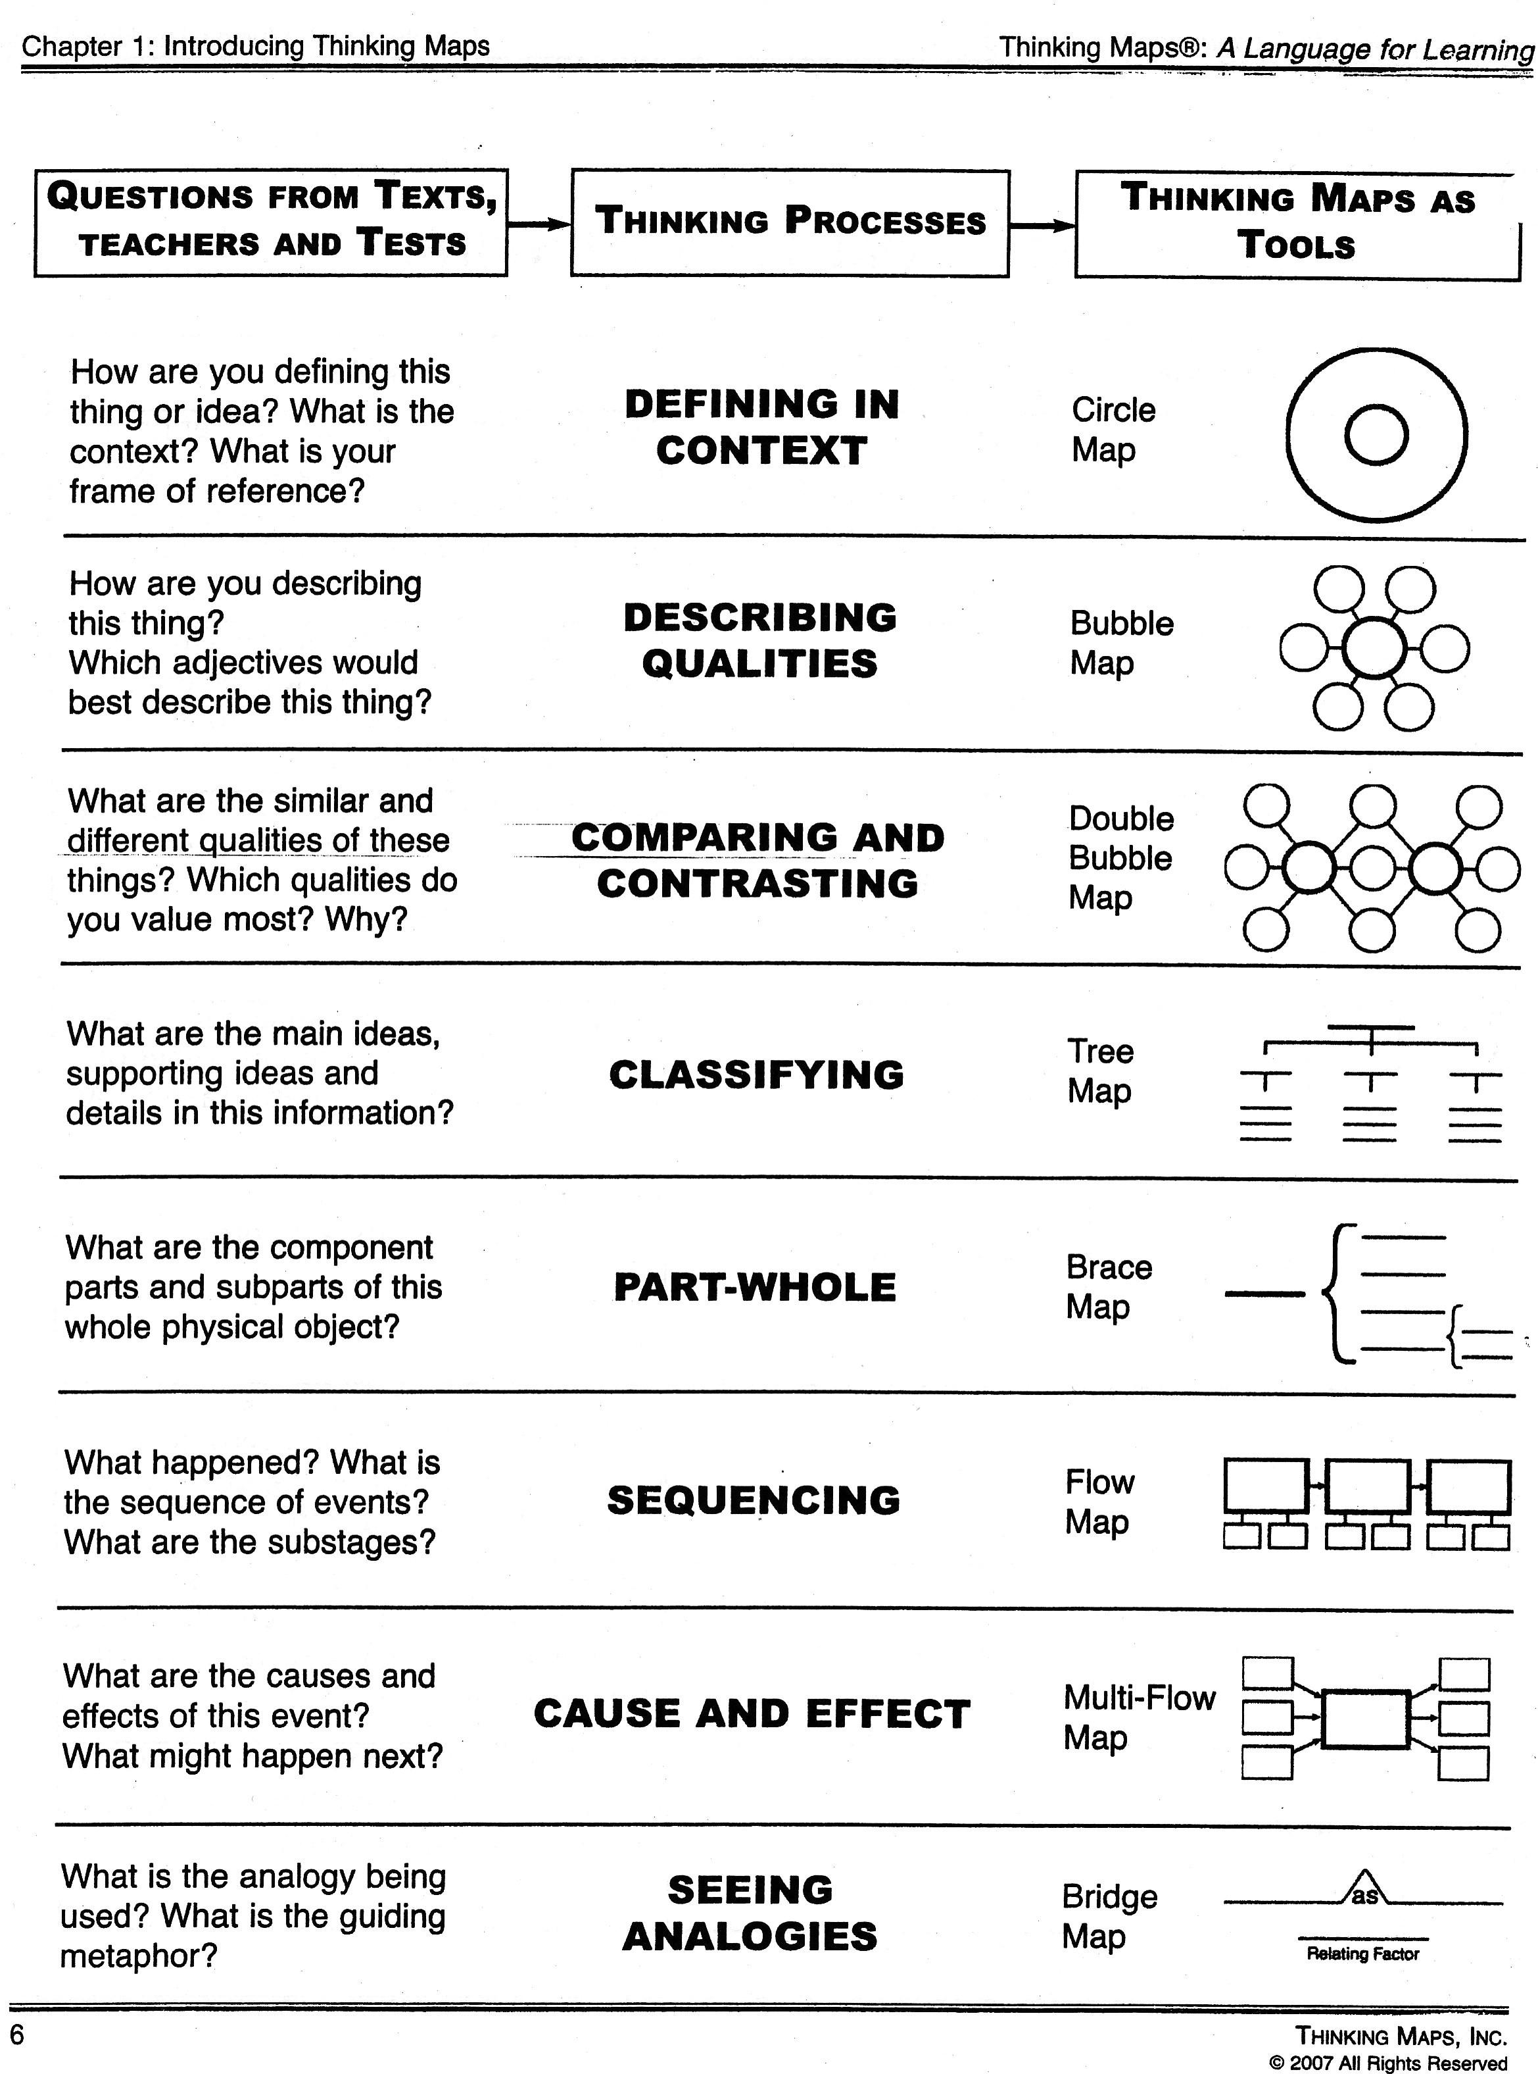

DeKalb Intensive English Curriculum

Formative And Summative Assessment Menu

**Assessment follows standards-based teaching.** We assess what we teach, the way we teach it. So our assessments are clearly aligned to our standards, our objectives and our descriptors and often the teaching strategies and materials we use are used again in our formative and/or summative assessments. We develop a rubric or checklist for or quiz to help us pay attention to student performance in classroom activities and products. If we are teaching to important standards, and the standardized assessments are based on them, we should be preparing learners to show what they have learned with effective and closely related formative and summative assessments. With a carefully aligned curriculum, student learning will eventually be demonstrated on standardized assessments.

**Assessment is continuous.** Formative assessment is part of each lesson, each day, during teaching and learning. Summative assessments evaluate student performance at the end of a unit of teaching and learning. Below are suggested assessments in each category, but you will no doubt find and use many others. Note that sometimes, formative assessments can become summative assessments. An assessment can be used during a unit or lesson in a formative way, and then used once more as the last step in a unit or project as a summative view of learning. An example might be how a rubric is used as a formative assessment with drafts of a piece of writing or speech, and then again as a summative assessment of the final product.

**Assessment guides instruction that follows.**  We look at previous assessments to find out where students are and what they need to know. We use our classroom formative and summative assessments in the same way -- how students perform determines how and what we should teach next, and how to differentiate for diverse learner proficiency levels in the class. Keep in mind that what we really teach are *students*, not the curriculum, and we need to adjust our teaching to match learner needs.

**Formative assessment examples:**

* One question quiz (oral or written or answered with signs or symbols)
* Entrance ticket: Each student answers a question/performs a task on entering the class
* Exit ticket: Each student answers a question/performs a task in order to exit class
* TPR: Students demonstrates understanding of language/content by an action, e.g., pointing, marking, choosing a picture, acting something out by creating a skit to demonstrate a meaning
* Pair-share – peers check one another’s comprehension and understanding and signal to the teacher.
* Numbered Heads – see strategy description
* Question-Answer-Relationship (QAR) – see strategy description
* Graphic organizer – see strategy descriptions
* Cooperative Sentences – see strategy descriptions
* Teacher observation of student product or performances using a rubric or checklist
* Self- or peer assessment of product or performance with rubric
* Word sort
* Personal dictionary, learning journal, and/or other product check
* Spelling or vocabulary or content quiz
* Cloze passage of text (with key words left out for students to complete, with or without word list) based on current learning
* Student self-assessment of appropriateness of an independent reading (e.g., the five finger test)
* Student self-rating of their levels of knowledge of terms or concepts on a scale
* Vocabulary Profiler analysis of learner writing
* Students distinguish between examples and non-examples
* Students/teacher use editing checklists and rubrics for writing
* Students keep and teacher checks running record of progress in a chart in the writing folders
* Teacher-kept records of participation, attendance, task completion
* Student products – writing, graphic organizers, notes, etc.

**Summative assessments:**

* Student product or performances (e.g., writing, speaking, audio recording, video, web task, lab notebook, personal dictionary, problem-solving, book talk, dialogue…) assessed with rubric, checklist or other guidelines that are clear to the learner and teacher
* Observation of student oral performance with rubric
* Assessment from online tool like Study Island
* Teacher paper and pencil test based on standards, objectives, and descriptors
* Assessments available through software programs.
* Tools like *Socrative* and tools available through *Edmodo* -- used to administer teacher-made online assessments that give immediate feedback to learners.

**Rubrics**

Rubrics are powerful tools for helping learners and teachers describe increments toward achievement of goals and to assess progress toward reaching objectives. Using the WIDA Performance Descriptors and WIDA Can-Do Descriptors, rubrics can be developed for your assessments in a format that parallels WIDA levels. Rubrics can help with differentiation – different students can be guided to aim for different levels, depending on their proficiency. The rubric on the right is designed for beginners learning about classroom expectations.

A tool for rubric creation is available at: <http://rubistar.4teachers.org/index.php>

Rubrics like these can also be designed for use in documenting mastery of the Can-Do Descriptors in the Intensive English Portfolios. The sample rubric on the following page follows the WIDA levels 1-3 and assesses multiple speaking and writing Can-Do descriptors at 3 levels.

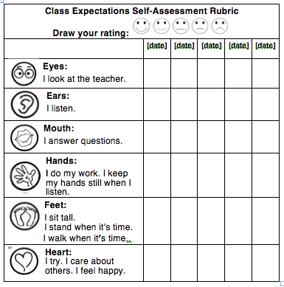

**Food Group Presentation Rubric**

Names:\_\_\_\_\_\_\_\_\_\_\_\_\_\_\_\_ \_\_\_\_\_\_\_\_\_\_\_\_\_\_\_\_ Date:\_\_\_\_\_\_\_\_

Circle one box for each row. Write notes at the bottom.

Total: \_\_\_\_ out of \_\_ / 6 / 12 / 18 (Circle level)

|  |  |  |  |
| --- | --- | --- | --- |
|  | **Entering - 1** | **Beginning- 1** | **Developing - 3** |
| **Introduction** | Gave an introduction with your name and the name of the food group | Gave an introduction with your name and the name of your food group. Used sentences to talk to the audience. | Gave a creative introduction that made the audience want to learn from you! Used a question, fun fact, and/or connection to the audience. |
| **Title & Author** | On the poster **or** in the presentation: named all group members and gave a title. | On the poster **and** in the presentation: named all group members and gave a title. | On the poster **and** in the presentation: named all group members and gave a **creative** title. |
| **Details about Nutrients** | Listed 1-2 vitamins, minerals, fiber, and other nutrients the food group has. Explained **one** of the ways that these nutrients help your body. | Listed 1-2 vitamins, minerals, fiber, and other nutrients the food group has. Explained **some of** the ways that these nutrients help your body. | Listed **3** or more vitamins, minerals, fiber, and other nutrients the food group has. Explained **all** the ways that these nutrients help your body. |
| **Sources** | Only used facts from the text.” | Used **one fact** from another source besides the text” | Included **2 or more facts** from **other** sources besides the text. |
| **Sentence length and variety** | Used words and phrases, but not sentences. Did not use correct punctuation and capitalization. | Used **mostly short** sentences. Began some sentences with “And.” Used **some correct** punctuation and capitalization. | Used **some** short sentences and **some** long sentences with and/but/so or “because.” Did not begin sentences with “And.” Used **mostly** correct punctuation and capitalization. |
| **Style** | Poster is neat. Seemed like you **weren’t sure some of the time, some pauses**. | Seemed like you had practiced, only a **few mistakes or pauses**. Poster is colorful and neat. | Seemed confident and **happy**- like you had practiced a lot. Poster is colorful, **decorated**, and neat. |

Notes:

*Macintosh HD:Users:Atalanta:Dropbox:1-projects-current:2014 Projects:DeKalb ESOL Curr:Newcomer Curriculum:Standards:CC_Anchor_Standards.pdf*

